**Group project proposal**

**Group Number:** 11

**Group Members:**

1)Ketul Kamleshbhai Patel (B00900957)

2) Sagarkumar Pankajbhai Vaghasia (B00878629)

3) Khushalkumar Maganbhai Gondaliya (B00912092)

**Course:** CSCI 5308 - Advance topics in software development

1. **Project title:** Library management system
2. **Overview:**

The Library Management System is a project which manages the internal functions of the library efficiently on daily basis as there are many books and resources available which is tough to manage manually. Traditionally, the management system worked on paper, and it was tedious to manage paper records. In our project, along with the functionalities we are also providing analysis to the admin for different aspects.

This system will have 3 users: Admin, Librarian and Users. Admin will be able to do all the operations of librarian and user. Apart from that a special functionality is also added for admin where an admin can view number of active users, librarians and books and analysis charts. Librarian can add books, delete books, update books, issue books, take return books and many more. It also has a facility where a user can search books, get list of currently issued books and update their profile.

Overall, our project mainly aims on reducing the human efforts as much as possible and to make smooth system for the functions of users.

Technologies will be used:

* Java
* HTML/CSS
* Bootstrap
* Spring Boot
* MySQL
* Thymeleaf

1. **Functionalities**:

* **Home page:**

* This will be the home page of the website. If the user has already created account, then user can login by providing userid (email) and password. The appropriate page will be displayed according to the user type (Admin, Librarian, General User). The credentials will be verified with database and if the credentials are incorrect then system will generate error to “enter valid credentials”
* Else user can create new account by clicking on create account button. The page will be directed to the create new account page.
* If the active users have forgot the password, then they can recover password by clicking forgot password button. The page will be redirected to the forgot password page.
* **Create account page:**

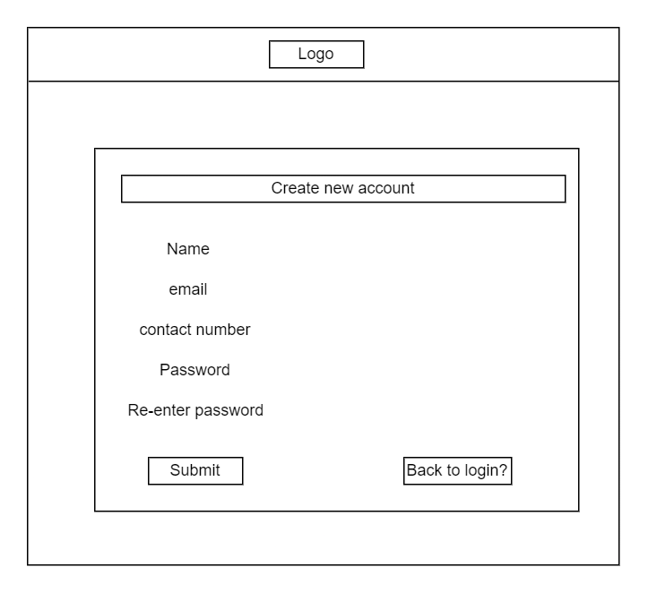

* The new user can create account by providing the decided credentials and clicking submit button. The data entered by user will be verified such as email-id and password and if they are correct then all the data will be stored in the database of users. Then it will be redirected to the home page of the website.
* If user wants to go back to login page, then user can go there by clicking back to login button.
* **Forgot password page:**

* If the active user has forgot his password, then user can recover password by providing email id.
* The password reset link will be sent on email. From that link, user can reset the password as there will be two fields available for new password and confirm new password. This new password will be reflected in the database when user will click on submit button.
* If the email id does not exist in database, then the appropriate error will be displayed on the page.
* The user can go back to login page or create account by selecting the back to login or create account button respectively.
* **Admin dashboard:**

* If the admin has logged on the website, then this page will be displayed to the admin.
* The page will contain the logo on the top-left corner and profile button on top-right corner. The profile will have dropdown containing view/edit profile, currently issued books, and logout buttons.
* The page will display the active number of users, libraries and number of books issued currently.
* There will be 3 -4 analysis charts on the page. To give an example for that, revenue generated last year monthly which will be fetched from the database.
* Admin can view/edit the personal details by clicking view/edit profile button, the page will be redirected to the view/edit profile page. And check the list of the book that are issued by him/her by clicking on currently issued books, the page will be redirected currently issued book page.
* From Left sidebar, admin can navigate to book, librarian, users, issue book and return book pages.
* Lastly, admin can logout from the website by clicking logout button.
* **Book :**

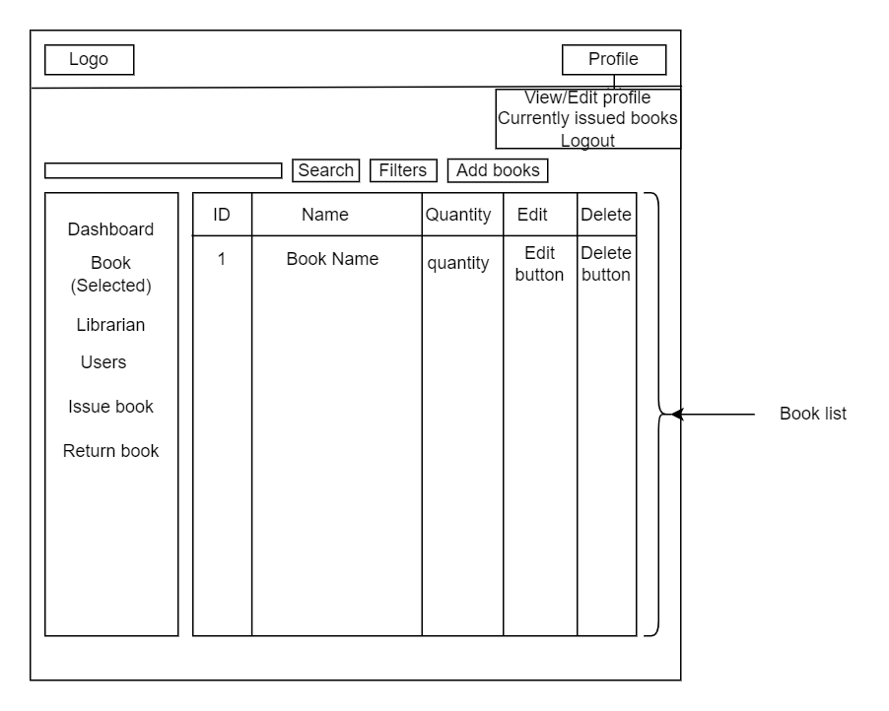

* This page will be displayed when admin will click on the book button from left sidebar of the admin dashboard.
* The page will show the list of books that are in the library and admin can edit, delete any book from the list by clicking the edit/delete button from the table which will reflect in the backend.
* The page will have the functionality of searching and filtering any books that are available in the database.
* Admin can add books to the library by clicking on the Add books button from the page.
* If admin want to check the list of librarian/ user, then he/she can do that by clicking on buttons provided left side below book.
* The pages will be redirected to the respected pages according to the click of the button.

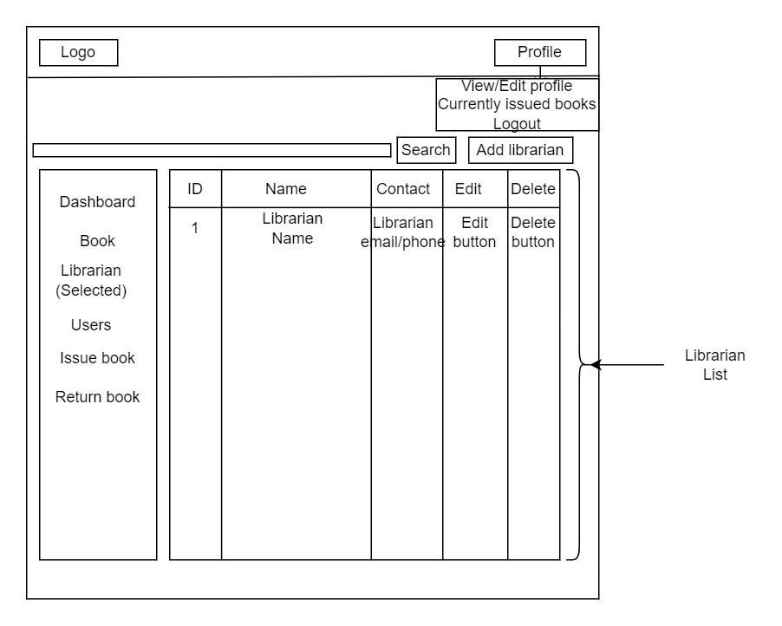

* The page will be displayed when the admin will click on librarian from the left panel and list of the libraries will be displayed on the page.

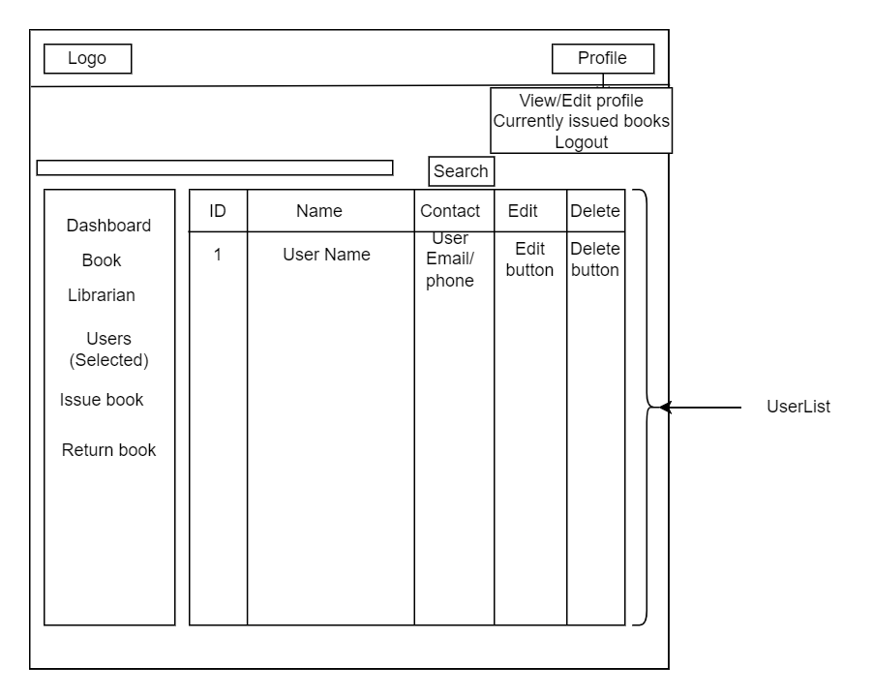

* The page will be displayed when the admin will click on user from the left panel and list of the users will be displayed on the page.
* **Librarian home page:**

* The librarian home page will have same header as the header of the admin.
* Librarian will have all the access of the admin except adding librarians to the database and librarian will not be able to see analysis charts. All other things remain same as the admin.

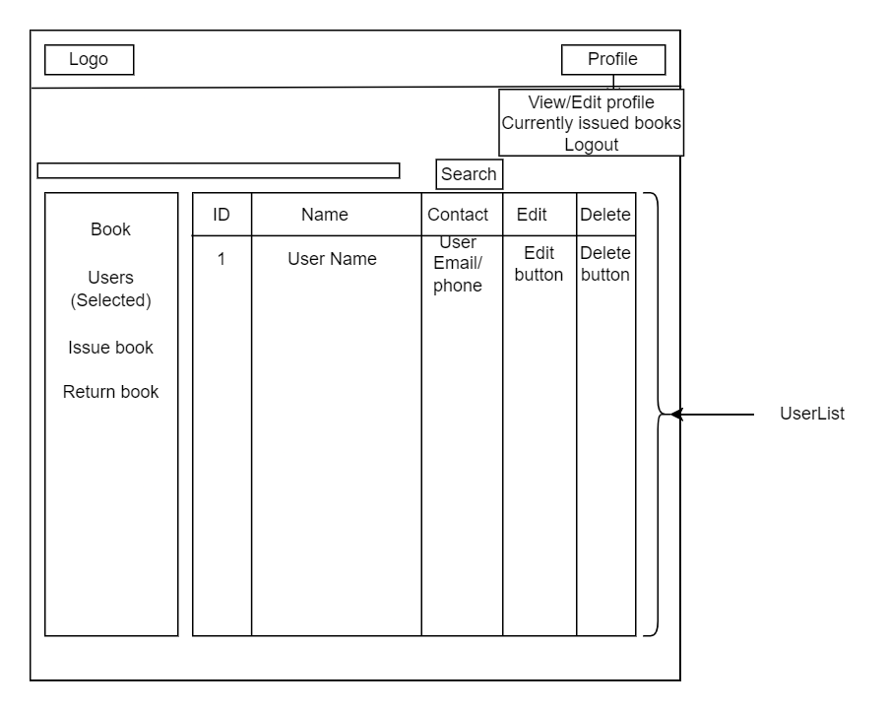

* The list of users will be displayed when librarian will click on the users from the left side panel. These records will be fetched from the database.
* **User home page:**

* The home page of the user will be the list of the books available in the library and user can search and filter specific book details by using the functionality of search and filter.
* User will be able to view/edit the personal information and check the books that are currently issued from respective buttons from the profile.
* The header of the page will be the same as the header of the admin.
* **View/Edit profile page:**

* This page will be displayed when any user will click the view/edit button and can change any personal information by clicking update button in the end. All the data will be updated to the database. Then the website will be redirected to the home page of the user.
* **Currently issued book page:**

* This page will be displayed when user will click the button currently issued books from the profile.
* It will list out all the books that are currently issued by the user along with having information about the given and return date for each book.
* **Update / Delete the book page:**

* The page will be displayed when admin/librarian will click the edit button for book.
* The details of the book will be displayed, and the admin/librarian will be able to update the data by clicking update button.
* The all the changes will be reflected on the database and then page will be redirected to the books page.

* The page will be same as update barring it will have the functionality of deletion of book. The book will be deleted from the database.
* **Update/Delete librarian page:**

* The page will be displayed when admin will click the edit button for the librarian.
* The admin will be able to change the personal details of librarian and all the data changes will be reflected on the database and website will be redirected to the librarian page of admin.

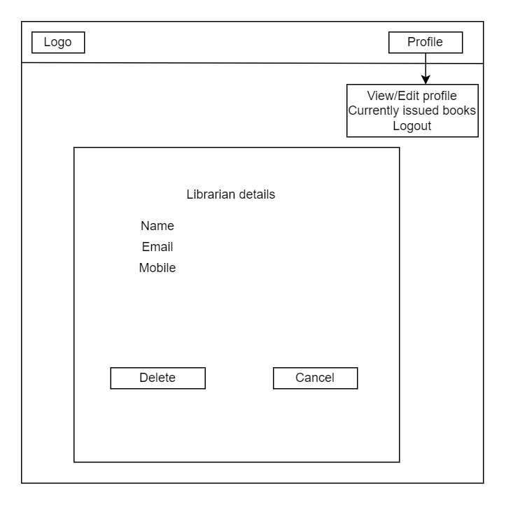

* The page will be same as update where it will have the functionality of deletion of librarian. The librarian details will be deleted from the database.
* **Add books page:**

* This page will be displayed when admin/librarian will click the add books button from books page.
* The books details such as name, quantity, type etc. will be provided by the admin/librarian and then by clicking on add book button the book will be added to the database and then page will be directed to the book page.
* Import from CSV will be the extra feature for the development where all details of the books will be stored in one CSV and the all the data from CSV will be added at once.
* **Add librarian page:**

* This page will be displayed when the admin will click on add librarian button from librarian page of admin.
* By collection of various attributes of librarian and clicking on add librarian button the librarian will be added to the database. Then, the page will be directed to the librarian page of admin.
* **Book details page:**

* This page will be displayed when the admin/librarian will click on the book name listed on the booklist.
* Book details will be provided with the details of users those have issued the same type of book from library.
* Admin/librarian can issue the book to the user or return the book from the user by clicking issue or return button respectively. The website will be redirected to the issue page or return page as per the click.
* **Issue/Return the book:**

* The page will be displayed when the admin/librarian will click on the button issue book from the left side panel of the home page or issue button from any book details page.
* By taking all the details about the book and user issuing the book, then clicking on the issue button, book will be issued, and the related changes will be reflected in the database. Then, the page will be redirected to the dashboard or home page.

* The page will be displayed when the admin/librarian will click on return button from the home page or return button from book details page.
* After clicking on return button, the invoice will be downloaded as pdf and changes related to book and user will be reflected to the database. Lastly, the page will be redirected to the book page.

1. **Project Plan:**

We have divided our project in smaller sprints to deliver the working website in shorter amount of time and keeping all 12 principles of agile methodology.

Applying agile methodology:

1. Organizing 2 to 3 scrums weekly.
2. Meeting TA on teams every Friday for progress of last week, further plannings and feedback.
3. Delivering working modules by following the best practices of clean code.

The estimated plan for the project completeness is mentioned in below table:

|  |  |  |
| --- | --- | --- |
| Duration | Sprints | Amount of work completed |
| 27 May – 03 June | Working CI/CD pipeline and design class diagram | 10% |
| 03 June – 10 June | Authentication | 20% |
| 10 June – 17 June | Authentication, Basic Library Functionality | 35% |
| 17 June – 24 June | Basic Library Functionality | 50% |
| 24 June – 01 July | Books Functionalities | 75% |
| 01 July – 08 July | Analysis report generation for admin | 85% |
| 08 July – 15 July | Refactoring the code | 95% |
| 15 July - 22 July | Presentation preparation | 100% |